# Session 2: Familiarization with Gcode and Slicing

## Gcode

3D printers (and CNC machines) use this code format called Gcode. This is a list of simple commands that tell the machine to move in x, y, and z axes and extrude to deposit material.

Reprap is the open-source community for 3D printing and it has a detailed page explaining every command in gcode here: <https://reprap.org/wiki/G-code>

We will be using very few commands but in case you are stuck and cannot find how to eliminate an issue, you can search the reprap gcode page.

## Slicers

Gcode is what 3D printers read and that’s what we will learn to make here. To check our answers i.e, check generated gcode, we need to use gcode viewers or slicers.

However, for that, we need to first have a sample gcode to see. Slicers take STL files (common 3D printer file format) and convert them into gcode.

Here is some information regarding STL files

1. Explainer video: <https://www.youtube.com/watch?v=1IIYZloCPSA>
2. Websites to get STL files: <https://www.youtube.com/watch?v=36uZkkQS-Gs>

Take a simple STL file from Thingiverse: <https://www.thingiverse.com/>

Sample file: <https://www.thingiverse.com/thing:5324529/files>

To convert STLs to gcode we use Slicers. Common slicers are:

1. CURA slicer: <https://ultimaker.com/software/ultimaker-cura>
2. PRUSA Slicer: <https://www.prusa3d.com/page/prusaslicer_424/>
3. Slic3r: <https://slic3r.org/>

We use CURA slicer here. Download and install CURA from the website. Follow the instructions in this video to get started with CURA. <https://www.youtube.com/watch?v=eUNTlb5pEWA>

Other online gcode viewers:

1. <https://gcode.ws/>
2. Good Gcode Viewer drag and drop: <http://jherrm.com/gcode-viewer/>

Write simple gcode for making a square by following this: <https://www.instructables.com/Manual-Gcode-for-3d-Stamp-Create-Square/>

Then check in online gcode viewers if you are able to see it. Make sure it works in at least one gcode viewer.

### Preliminary understanding of CURA slicing and gcode

Steps to get CURA and gcode from it:

1. Install CURA slicer (0:00 to 2min:40s): <https://www.youtube.com/watch?v=eUNTlb5pEWA>
2. Get 3D file: Take a simple STL file from Thingiverse: <https://www.thingiverse.com/thing:5324529/files>
3. Slice a 3D file in CURA and get the gcode file: <https://www.youtube.com/watch?v=Fvt8sz57W9Q>

Deeper understanding of gcode before you get to editing: <https://www.youtube.com/watch?v=2TByiMNduss>

Explore more details about slicing and 3D printing through the channel Teaching Tech: <https://www.youtube.com/channel/UCbgBDBrwsikmtoLqtpc59Bw>

Specifically for slicing, watch:

1. Beginners guide to slicing in PRUSA: <https://www.youtube.com/watch?v=yXNZ_2-rHNE>
2. CURA slicing: <https://www.youtube.com/watch?v=l_wDwySm2YQ>. This video also gives download link for CURA.

Videos to get 3D files to practice slicing:

1. 10 interesting things: <https://www.youtube.com/watch?v=Cp8cqAroWjw>
2. Meaningful uses for 3D printing in Gardening: <https://www.youtube.com/watch?v=71-nQTSJ17Q>. This video is made by Joseph Prusa himself! The guy who invented the PRUSA slicer!!

The descriptions of these videos have a lot of 3D files which you can try out.

### Editing CURA Code

Refer to these videos for manipulating gcode after slicing:

1. See and edit gcode after slicing: <https://www.youtube.com/watch?v=dX_Msr9ZmF8>
2. Modifying gcode to change settings at a set layer: <https://www.youtube.com/watch?v=nJS99c_7KiQ>

This is what we will try to do here. Once we do this successfully. Next time, we will generate our own code from scratch!

So this is how you start with our edit:

Copy paste the top few lines of code in the file generated with CURA and then type the gcode you made yourself and see if you can see it in CURA. In other words, in the entire gcode, change only the lines that have gcode movement commands (G1 X… Y… Z… E…). Start by cutting out existing lines and adding yours instead such that the change is clearly visible in CURA. Then keep replacing lines until you get your desired gcode in the view.

Follow the following steps:

1. Delete all lines which start with a semicolon ( ; ). These are commented lines and don’t get executed

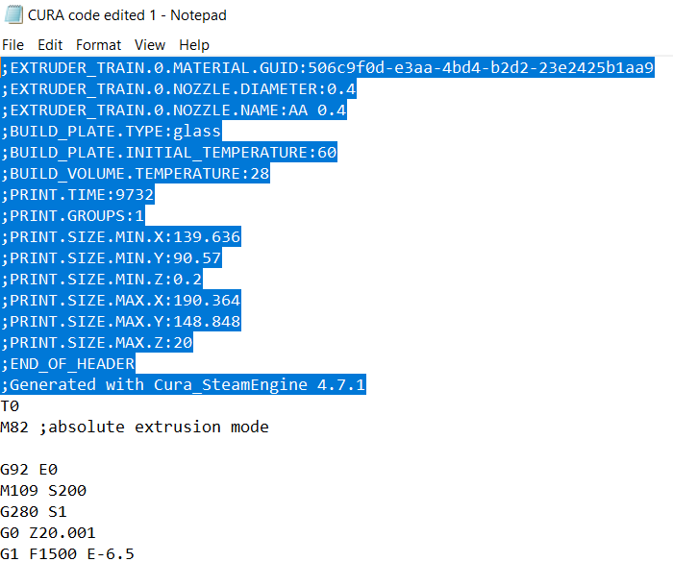

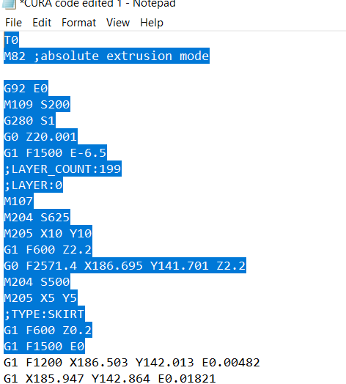

1. Keep everything before the first extrusion line. The first extrusion line would be after the line that shows E0 where E gains the first non-zero value. (E0.00482 in this case).

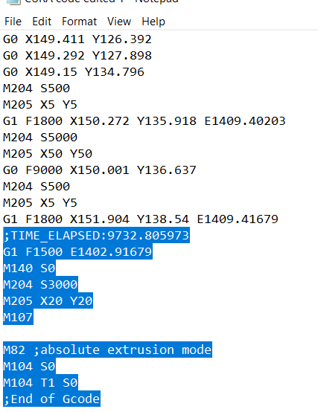

1. Keep the last lines after the end of the G1 and E… lines. Only copy after the last E… line.
2. The text in between can be edited to put your desired tool path. The portion marked in red is the effective area where you can write the code.

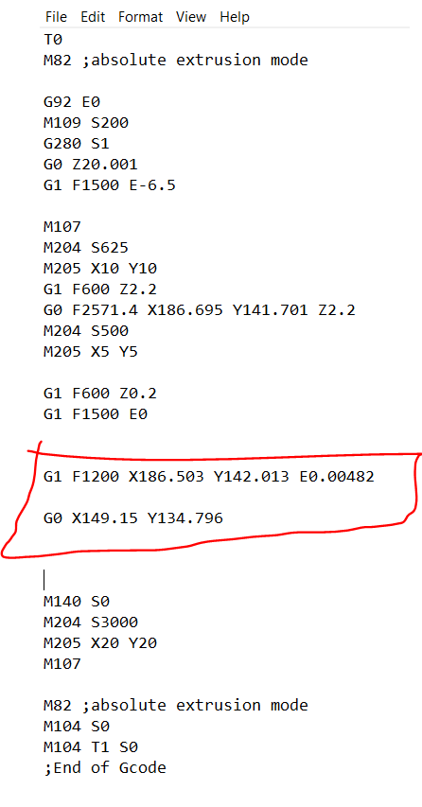

### Calculating Extrusion per unit distance

Take any snippet of the gcode from the middle with consecutive position and extrusion values like this region marked in red.

Here are a few values copied to text:

1. G1 **X185.732 Y143.174** E0.02318
2. G1 **X185.131 Y143.993** E0.03655
3. G1 X184.882 Y144.312 E0.04188
4. G1 X184.228 Y145.102 E0.05539
5. G1 X183.995 Y145.37 E0.06006

Point 1 in (X,Y) coordinates is: (185.732, 143.174)

Point 2 in (X,Y) coordinates is: (185.131, 143.993)

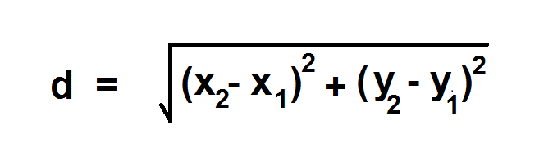Difference in extrusion is Edif (E2-E1) = 0.03655 - 0.02318 = 0.01337

Distance between 2 points is:

Thus, the distance between point 1 and point 2 is:

Extrusion per unit distance is: Edif/d = = 0.013161 units/mm = Erate

Check this value for other points like between point 5 and point 4.

So, predict that

We see that:

Once satisfied, use that value for the extrusion rate.

Using these values, hand write a gcode that can be viewed in CURA. Once you can do that, then we can move to automating the process and using C++ to write the code.

Assignment: make one simple gcode which can be viewed in CURA by copy pasting in a notepad file. Use C++ file handling to generate the same notepad file with “.gcode” extension.

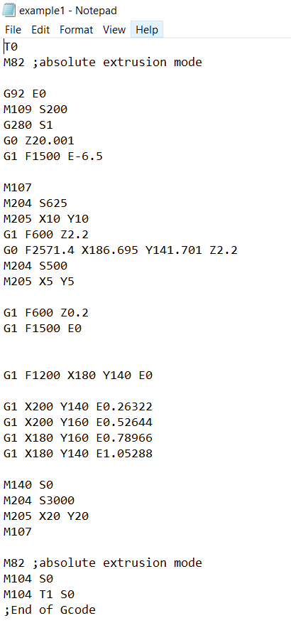

Sample

